Model End Assignment
Raw data was placed in separate sheets to ensure efficient data cleaning, transformation, and preparation.
Customer DIM Sheet
Step 1: Identified the missing value in the Loyalty Level column of the Customer Dimension sheet using the MODE function. Since “Platinum” appeared most frequently, the blank value was filled with “Platinum.
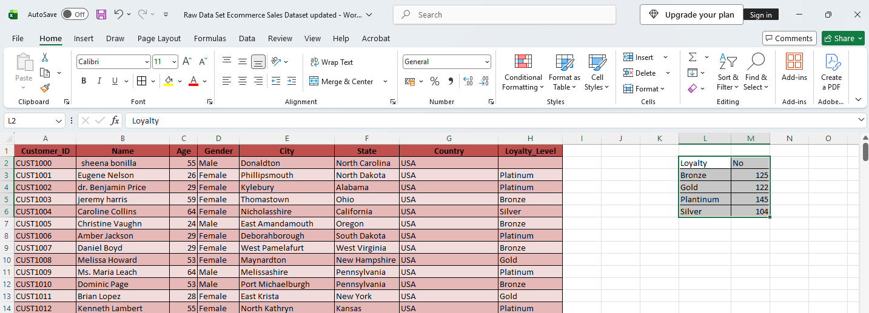
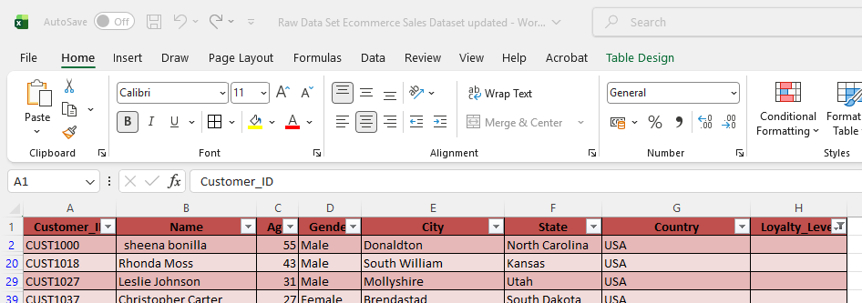
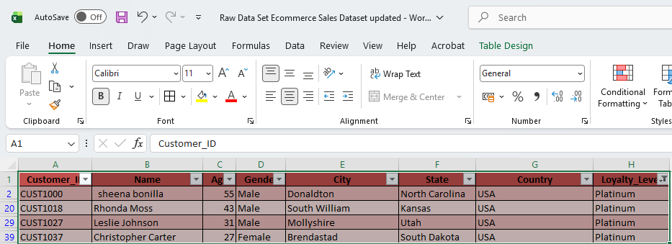

Step 2: Resolved the inconsistent data in the Customer ID column by comparing it with the provided data and making the necessary corrections
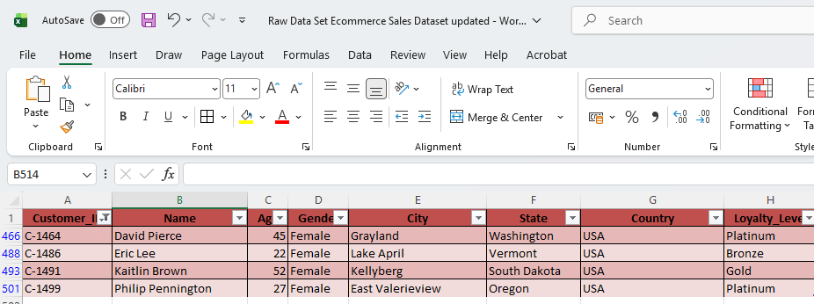
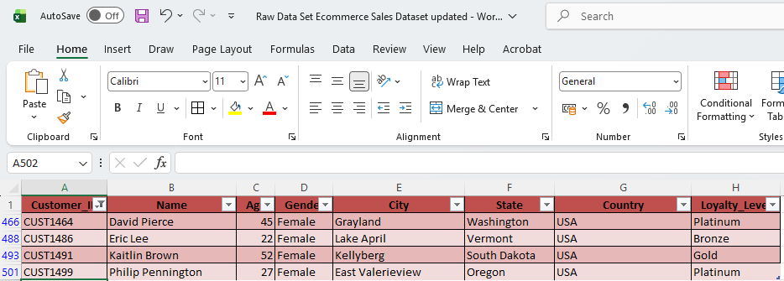

Step 3: Used PROPER, TRIM, and Find & Replace functions to clean the data in the Column Name
Used the PROPER function to capitalize the first letter of each word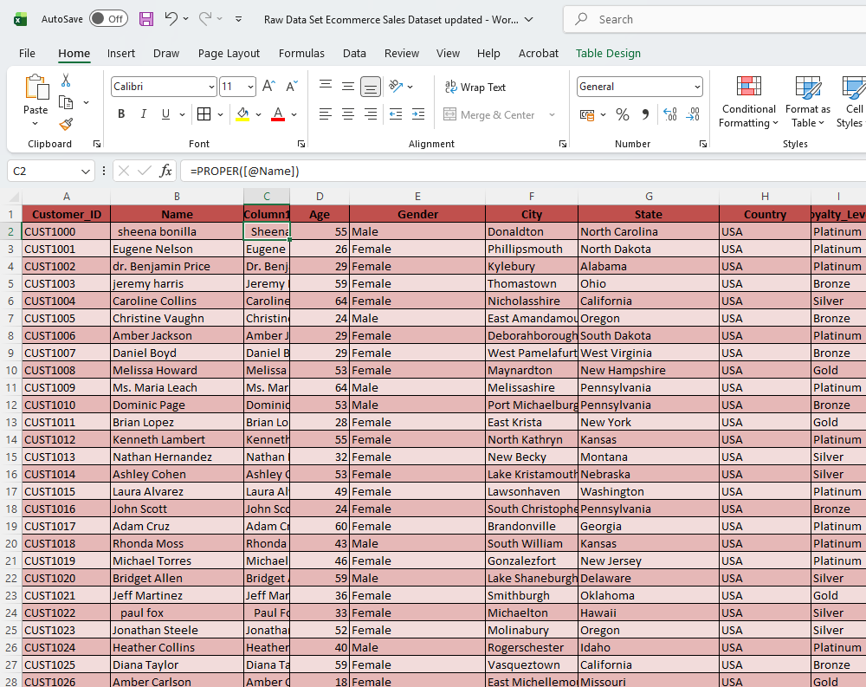

Used the TRIM function to remove extra spaces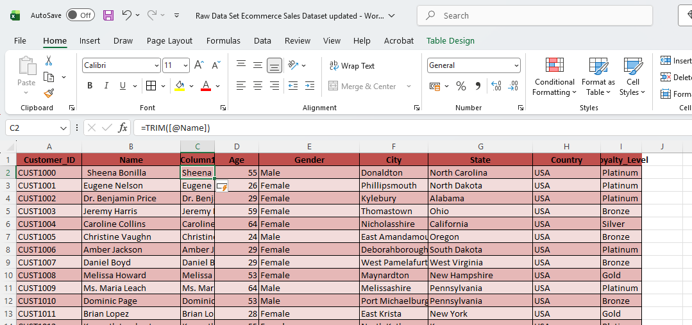

Used Find & Replace Function to remove titles such as Dr, Mr, Ms, DDS, Jr, MD, and PhD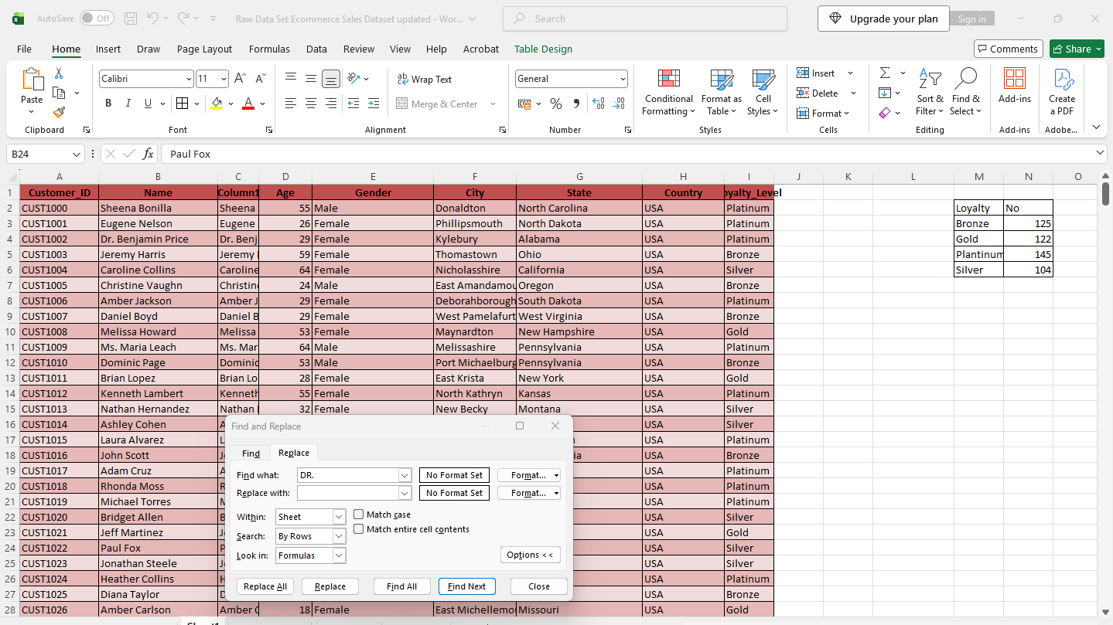

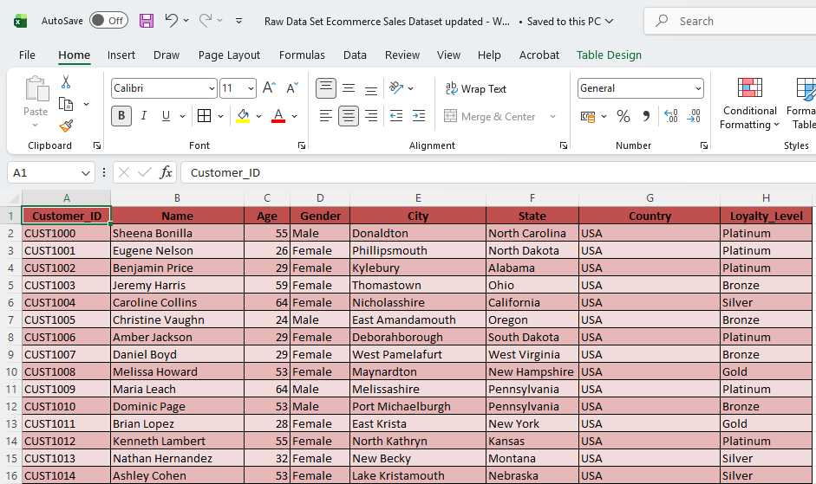

Step 4: Used Find & Replace Function to change “United States of America” to “USA.”
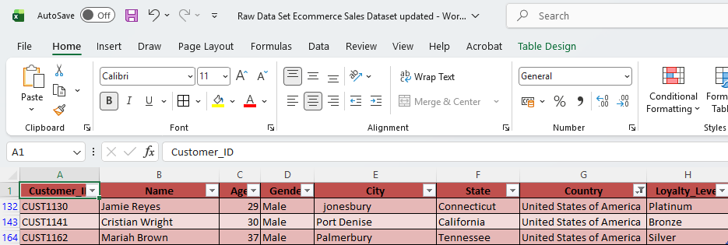
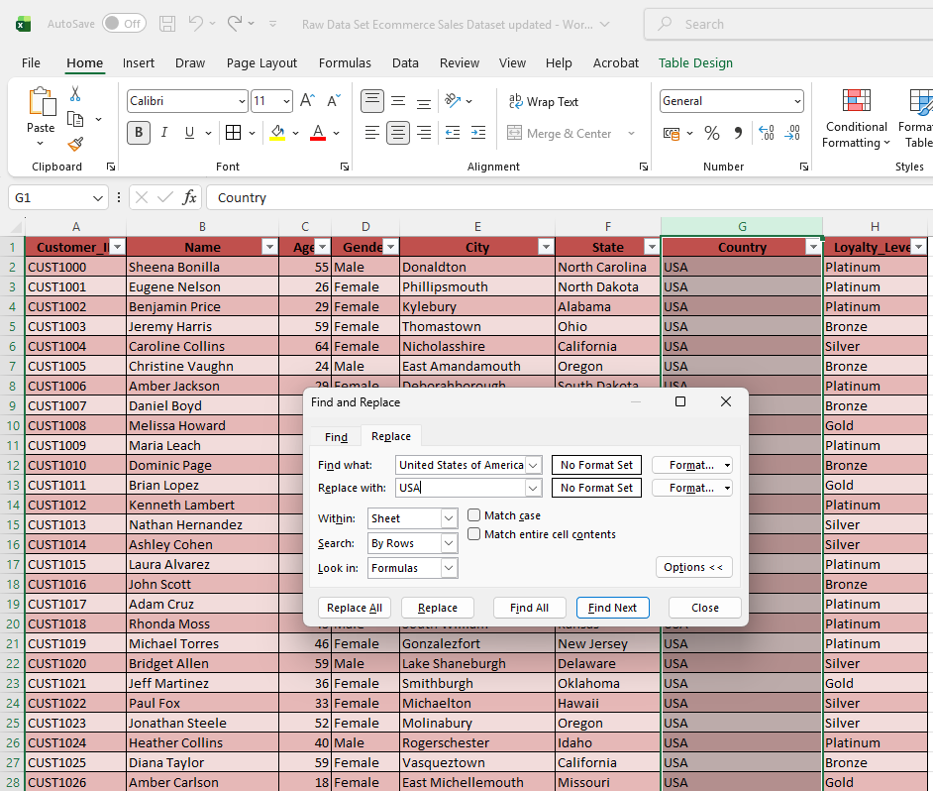
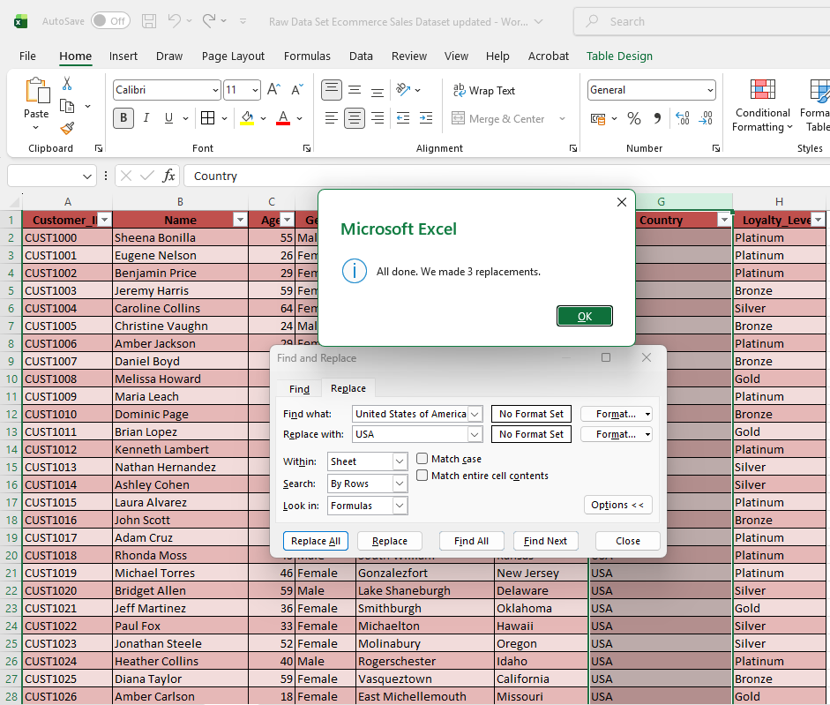

Step 5: Merge the State and Country columns into a single column named State_Country using the CONCATENATE function.
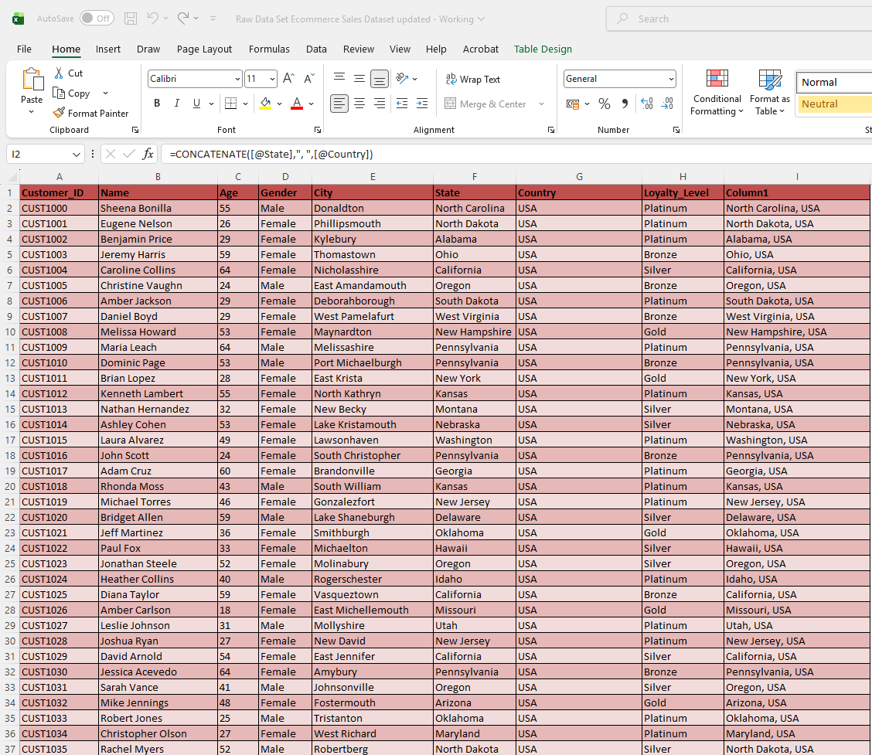

PRODUCT DIM
Step 1: Resolved the inconsistent data in the Customer ID column by comparing it with the provided data and making the necessary corrections.
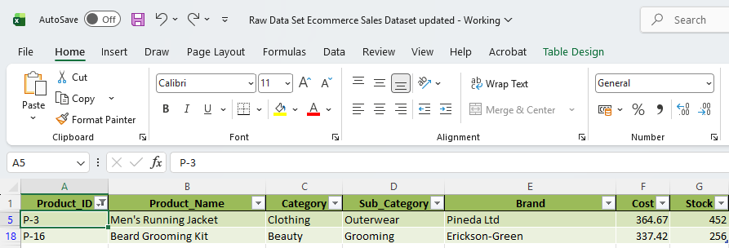
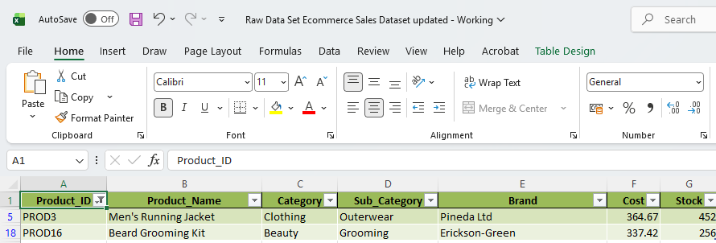

Step 2: To identify the missing values in the Cost column, the VLOOKUP function was used to retrieve the corresponding Unit Price from the Sales Fact sheet. Since the Sales Fact sheet contains multiple Unit Prices for each Product ID, the data was first sorted by Date in descending order. VLOOKUP was then used to retrieve the latest Unit Price for each Product ID and populate the missing values in the Cost column.

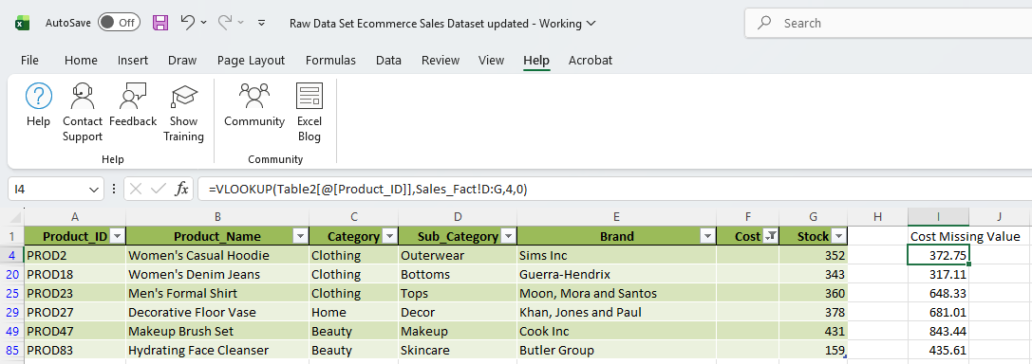
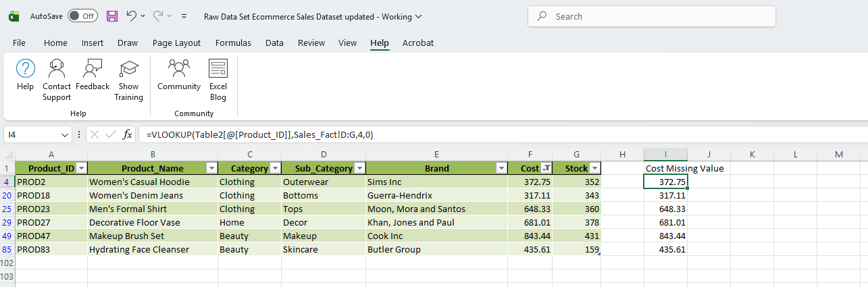
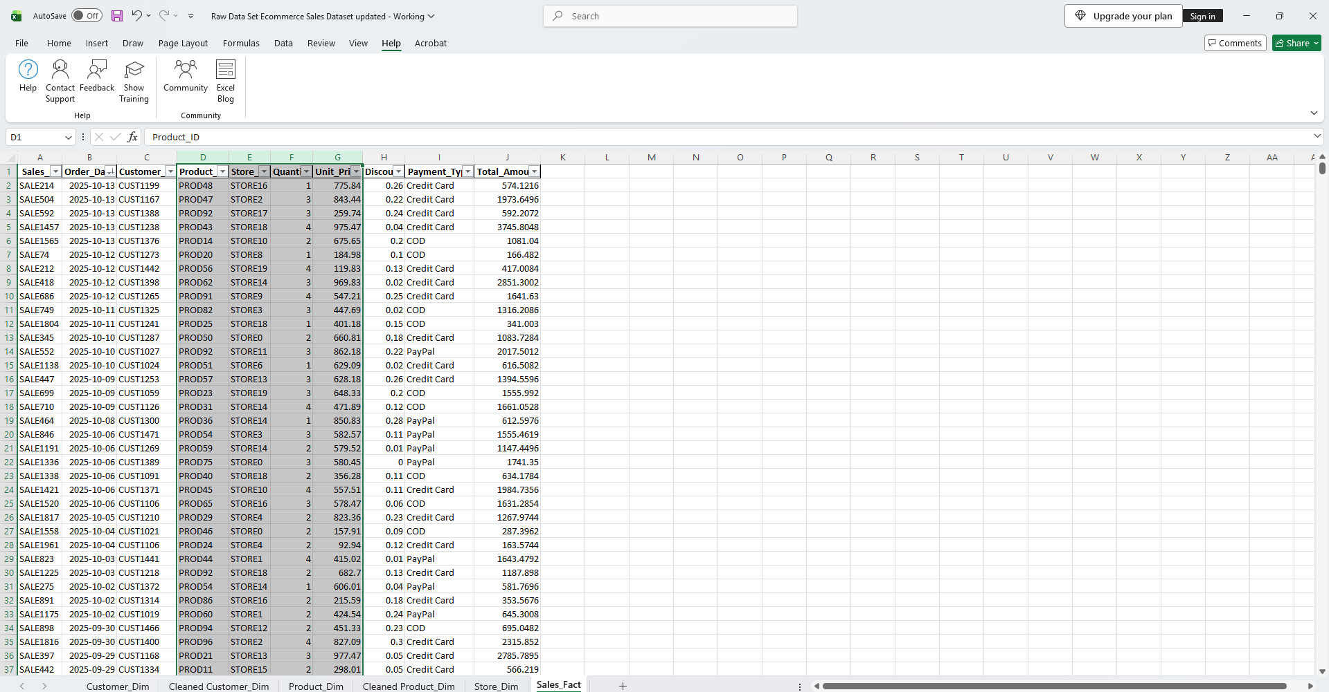

Step 3: Missing values in the Stock column were imputed using the MEDIAN function based on the corresponding Category and Sub-Category.
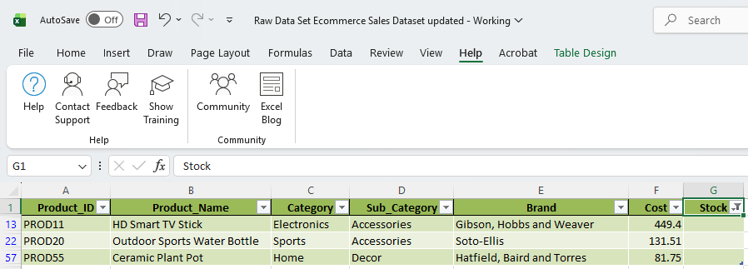

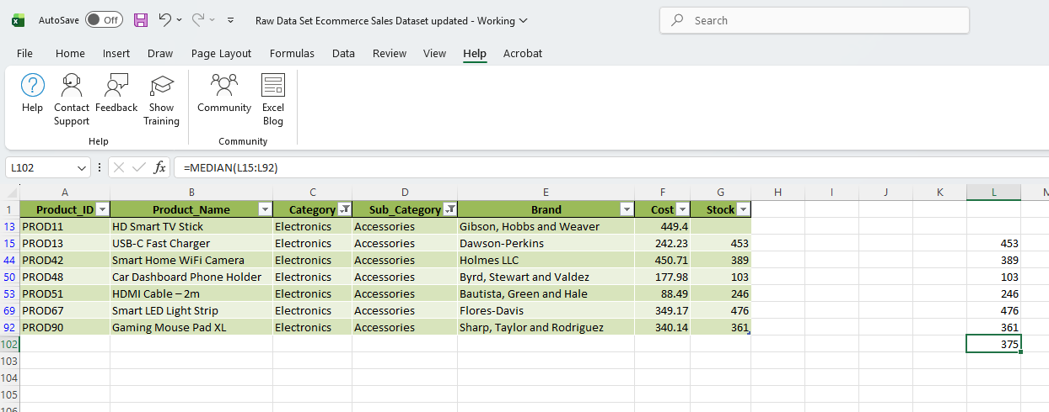

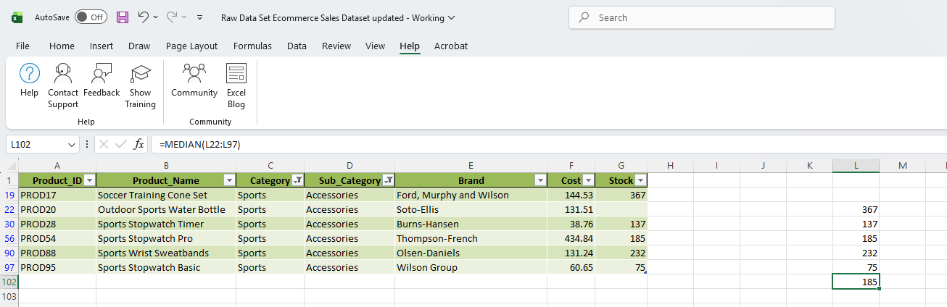

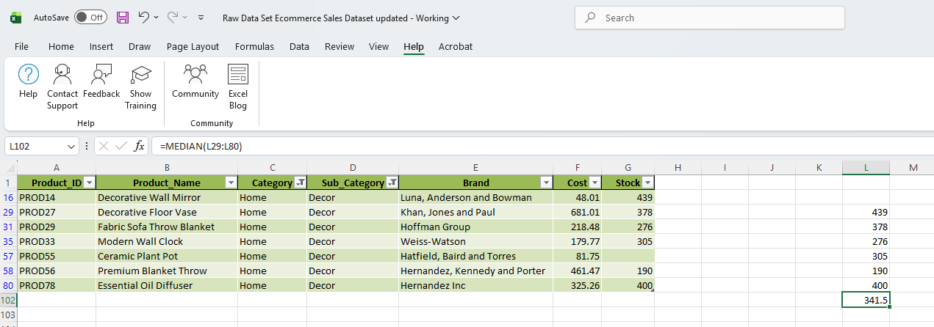

Store _ Dim
Converted Store _ Dim Data into Table
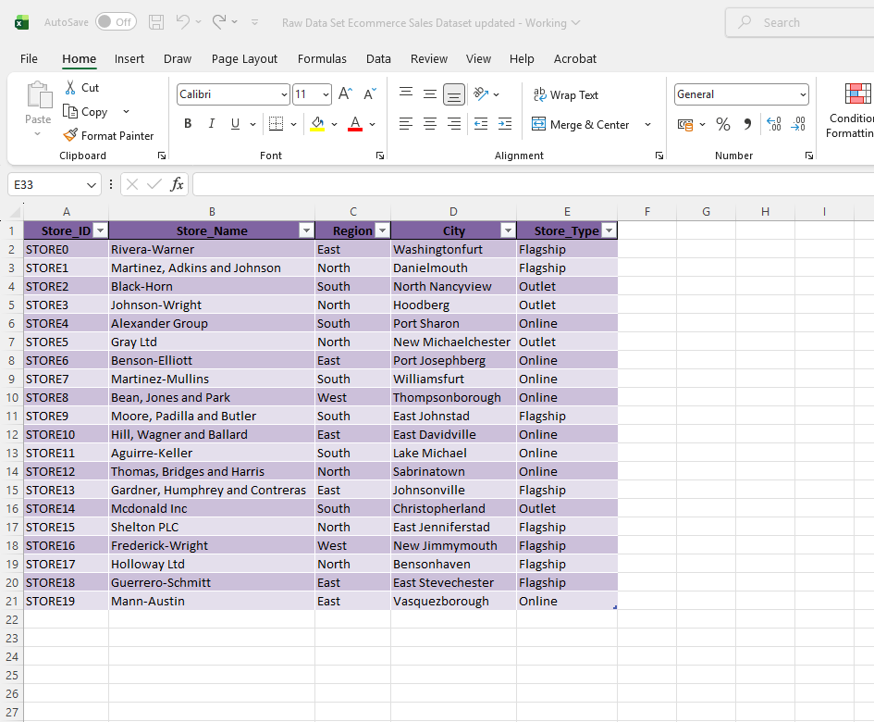

Sales Fact
Step 1: To identify the missing value in the Quantity used the below formula to calculate the Missing Value

Quantity = Total Amount / (Unit_Price*(1-Discount))
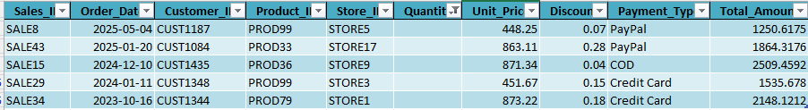

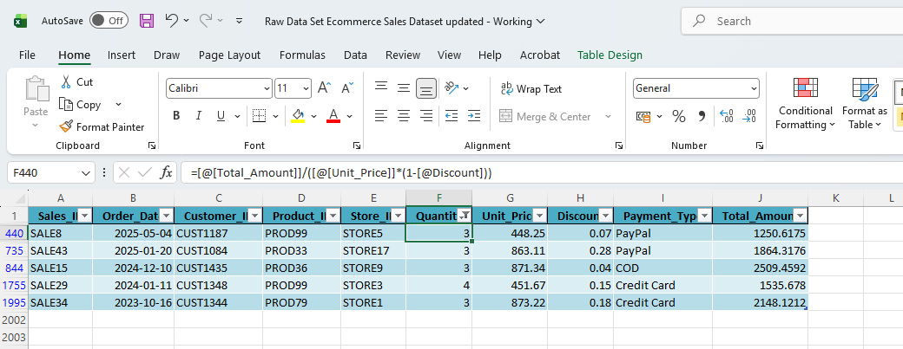

Step 2: To Identify the Missing Discount Values
Discount = 1-(Total Amount/(Quantity*Unit_Price))
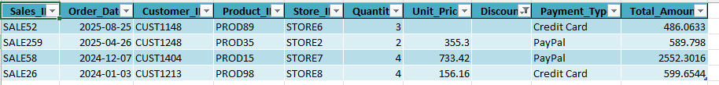

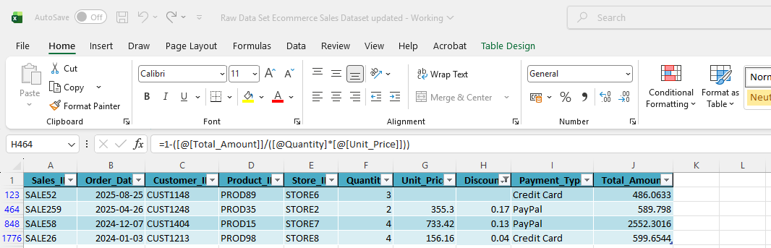

Step 3: To Identify the Missing Unit Price
Unit price = Total Amount /Quantity * (1-Discount)

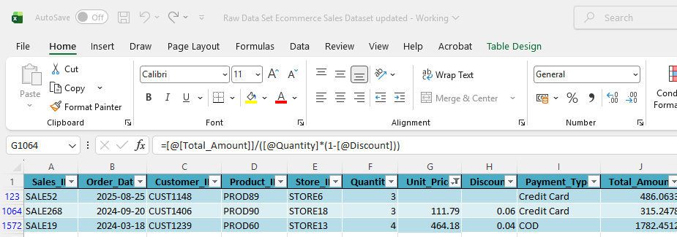

Step 4: To Identify the Missing Total Amount
Total amount = (Quantity*Unit_price)*(1-Discount)
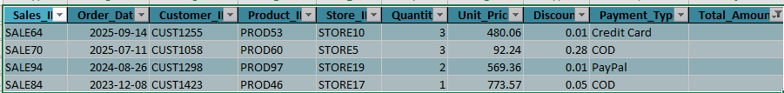
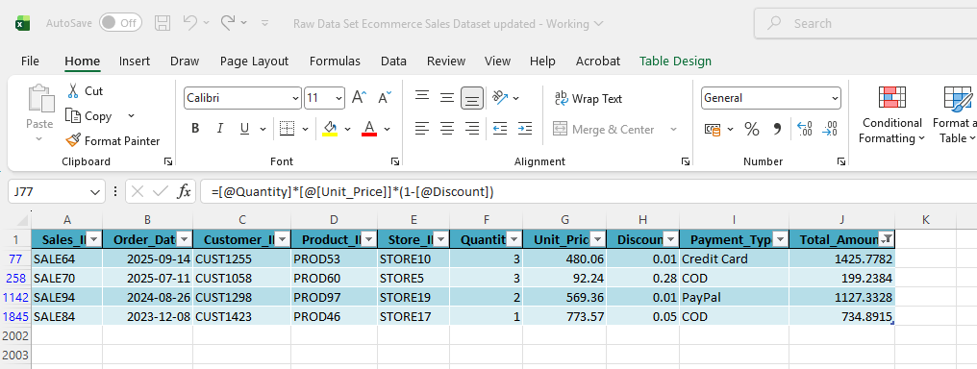

Step 5: Used Analysis ToolPak In Total Column
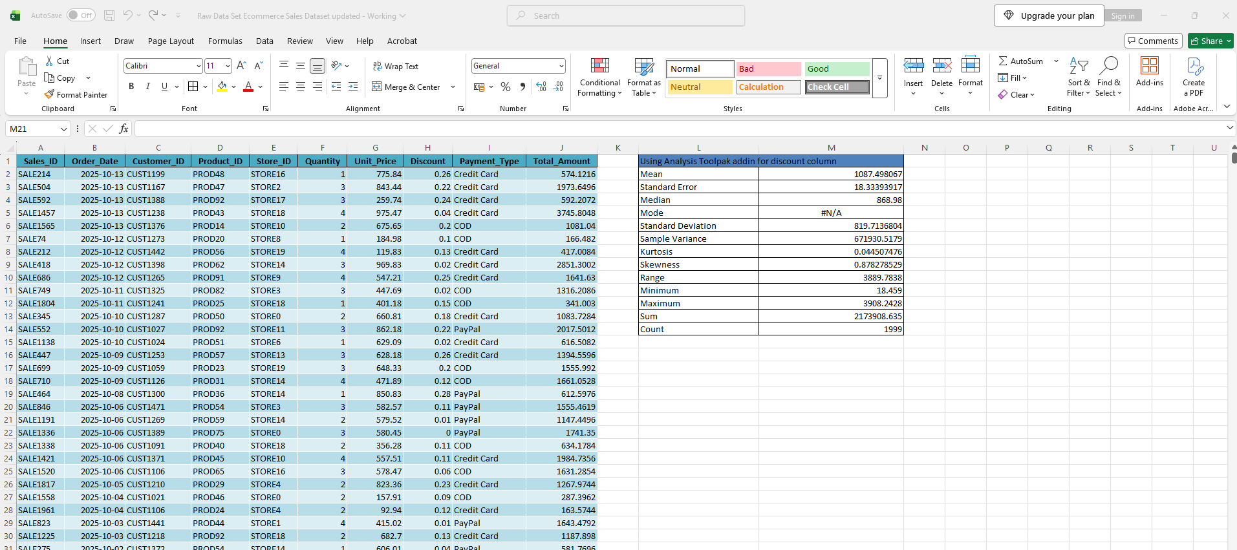

Pivot Tables & Charts
